UNIT IV – Suggested Lab Programs (Python)

Lab Program 1: K-Nearest Neighbors (KNN) Classification – From Scratch
PROGRAM CODE
from sklearn.neighbors import KNeighborsClassifier

# Step 1: Training data (features)
X = [[1, 2], [2, 3], [3, 4], [6, 7]]
y = [0, 0, 0, 1] # labels

# Step 2: Create KNN model (k = 3)
knn = KNeighborsClassifier(n_neighbors=3)

# Step 3: Train the model
knn.fit(X, y)

# Step 4: Predict for new data
result = knn.predict([[2, 2]])

print(result)
OUTPUT

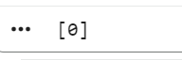

Lab Program 2: KNN with Model Evaluation
from sklearn.neighbors import KNeighborsClassifier
from sklearn.model_selection import train_test_split
from sklearn.metrics import accuracy_score

# Step 1: Sample dataset
X = [[1,2], [2,3], [3,4], [4,5], [6,7], [7,8]]
y = [0, 0, 0, 1, 1, 1]

# Step 2: Split data into training and testing
X_train, X_test, y_train, y_test = train_test_split(
X, y, test_size=0.3, random_state=1
)

# Step 3: Create KNN model
knn = KNeighborsClassifier(n_neighbors=3)

# Step 4: Train the model
knn.fit(X_train, y_train)

# Step 5: Predict on test data
y_pred = knn.predict(X_test)

# Step 6: Evaluate the model
accuracy = accuracy_score(y_test, y_pred)

print("Predicted values:", y_pred)
print("Accuracy:", accuracy)
OUTPUT
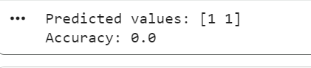
Lab Program 3: Locally Weighted Regression (LWR)
PROGRAM CODE
import numpy as np
X=np.array([1,2,3,4,5]); y=np.array([2,4,6,8,10])
x0=3; tau=0.5
w=np.exp(-((X-x0)**2)/(2*tau*tau))
print(np.sum(w*y)/np.sum(w))
OUTPUT
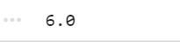
Lab Program 4: Radial Basis Function (RBF) Network for Classification
PROGRAM CODE
import numpy as np
X=np.array([[1],[2],[3],[6],[7]]); y=np.array([0,0,0,1,1])
c=[2,6]
R=np.exp(-((X-c[0])**2)); R=np.c_[R, np.exp(-((X-c[1])**2))]
print((R[:,1] > R[:,0]).astype(int))
OUTPUT
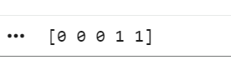
Lab Program 5: Case-Based Learning System
PROGRAM CODE
cases = [[1,2],[2,3],[6,7]]
labels = [0,0,1]
new = [2,2]
d = [abs(c[0]-new[0]) + abs(c[1]-new[1]) for c in cases]
print(labels[d.index(min(d))])
OUTPUT
